Extraction of data using python code

- We will be using a Python library called Tweepy to connect to Twitter Streaming API and downloading the data.
- Along with that we will be using the access_token, access_token_secret, consumer_key, and consumer_secret from the twitter developer account.

Note: Every 1 hour the above tokens needs to be regenerated.

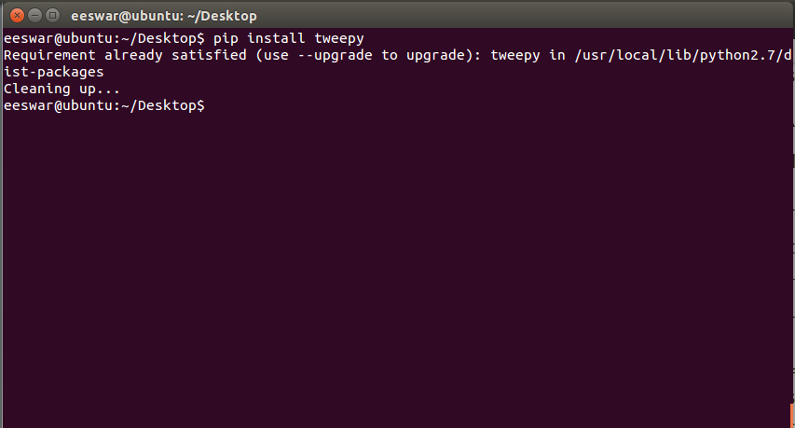

In the above screen-shot:
- As we have already installed tweepy, it is saying - “Requirement already satisfied “.
- It is showing the path where tweepy is located.

- Next we have created a file pro2.py and type the code below:

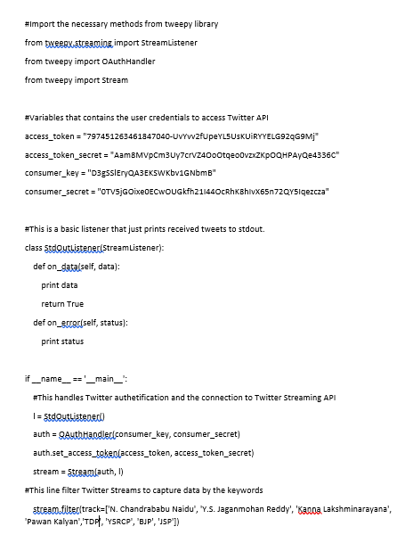
XXXXXXXXXXXXXXXXXXXXXXXXXXXXXXXXXXXXXX
XXXXXXXXXXXXXXXXXXXXX
XXXXXXXXXXXXXXXXXXXXXXXXXXXXXXXXXXXXXX
XXXXXXXXXXXXXXXXXXXXXXXXXXXXXXXXXXXXXXX

- We use the command python file_name.py to run any python code using terminal.
- For storing all the data that is collected, we have to create a text file. Here, we have created twitter_data5.txt

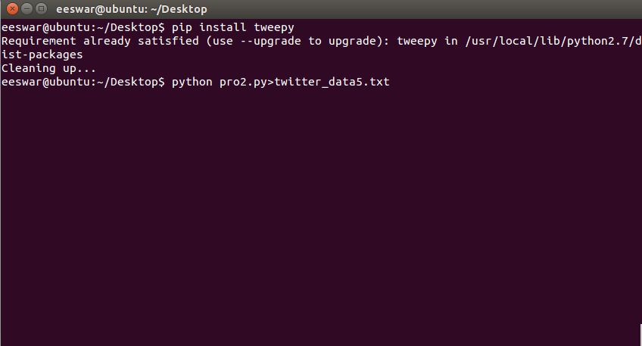

- If you run the program from your terminal using the command: python pro2.py>twitter_data5.txt, you will see data flowing like the picture below.

